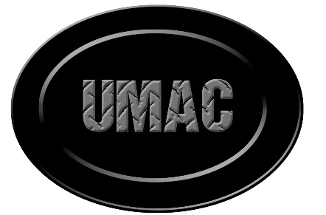
Utility Management and Construction LLC
2038 West CR 900 North Roachdale, IN 46172 telless@umac3.com 765-522-1024

AGREEMENT
This Agreement is made with the Town of Lapel (hereinafter referred to as ‟Town”) and Utility Management and Construction LLC (hereinafter referred as ‟UMAC”).
WITNESSETH:
The Town retains and contracts with UMAC for a period beginning the 1st day of November 2024 and ending the 31st day of October 2025.

UMAC agrees:
- To maintain the necessary licenses to operate the Town’s water and wastewater treatment facility.
- To work with and direct Town of Lapel employees in the operations of the water and wastewater facilities.
- To be on site as needed and to be determined by the operations staff of UMAC.
- Operate the water and wastewater facility in a manner that ensures maximum efficiency of that facility.
- To complete the monthly report of operation.
- To maintain compliance with the NPDES Permit and any agreed orders provided by IDEM.
- All records and reports generated shall remain the property of the Town.
- To cooperate and follow all safety guidelines set forth by local, state and federal agencies.
- To immediately report all abnormal situations to the Town Council and or IDEM.
- To respond to all reported emergencies within (4) hours from time of notification.
- To provide the Town Council with a verbal or written monthly reports.

The Town agrees:
- To provide employees to do the daily operations of the water and wastewater treatment facilities.
- Allow UMAC to direct utility employee in the operation of the water and wastewater treatment facilities.
- To supply all required chemicals and testing equipment.
- To supply UMAC with the required assets to maintain compliance with the NPDES Permit and any agreed ordered.
- To compensate UMAC ($4800.00) monthly plus hourly employee wages monthly as stated above.
- To review UMAC performance and compensation at the contract renewal time.
- To compensate UMAC $85.00 per hour for work done outside the scope of this contract. This work will be preapproved by the Lapel Town Council.

Compensation for Services Rendered:

- The Town agrees to pay UMAC $4800.00 monthly, to be payable within Thirty (30) days of invoicing.
- All other compensation in addition to the monthly base fee will be invoiced to the Town as it occurs and shall be payable within Thirty (30) days of invoice date

Termination:
Either party may terminate this agreement upon a 30- day written notice to the other party or earlier with written mutual consent.

Payment of Tax
All payments shall be made to UMAC, whom shall be responsible for the payment of all federal income taxes, social security taxes, and state income tax.

Employment Benefits:
UMAC agrees to waive any employment benefits Insurance as and Pension plan payments. In no way is UMAC considered to be employees of the Town of Lapel and is serving solely as an independent contractor.

Indemnification:
To the extent permitted by law, UMAC shall indemnify, defend, and hold the Town harmless from all damages, losses, claims, including claims and actions relating to injury or death of any person, or damage to property, demands, suits, recoveries, cost and expenses, court costs, attorney fees, and all other obligations by or to third parties, arising solely out of or resulting solely from UMAC’s performance of its obligations.

Agreed/Approved:
Board of Directors:
Date: ____________ ___________________________________________
Town Council President

___________________________________________
Town Council Member – Attest

UMAC
Date: _____________ ___________________________________________
Steven T. Elless, Managing Partner

